|  |
| --- |
| **Vehicular Traffic Flow Scenario Development environment**  **TEAM-ID: MITF12-29**  **CANDIDATES**  Shmeel Ahmad – MITF12M019  **SUPERVISOR**  DR. WAQAR UL QOUNAIN JAFFRY  ASSISTANT PROFESSOR  PUCIT, LAHORE  http://upload.wikimedia.org/wikipedia/commons/b/b0/PUCIT_Logo.png  **MASTER OF SCIENCE IN**  **COMPUTER SCIENCES – FALL 2012** |
| **Artificial Intelligence and Multidisciplinary Research Laboratory**  **PUCIT, University of the Punjab, Allama Iqbal Campus**  **54000, LAHORE, PAKISTAN** |

|  |  |  |
| --- | --- | --- |
| http://upload.wikimedia.org/wikipedia/commons/b/b0/PUCIT_Logo.png | M.Sc. CS  **Vehicular Traffic Flow Scenario Development Environment**  By  Shmeel Ahmad - mitf12m019 | |
|  |
|  |
| Approved  2013-07-01 | Examiner  Mian Mubashar | Supervisor  Dr. Waqar ul Qounain Jaffry |
|  | Project Office  Ch. Ejaz Ashraf | Contact Person  Shmeel Ahmad |

# Abstract

Traffic congestions and irregular traffic flow have been problem for long time of industrial and populated countries due to increased air and noise pollution and fuel usage. Computer aided traffic flow simulations help to develop environment for different traffic situations and to analyze related problems. The proposed Vehicular Traffic Flow Scenario Development Environment (TDE) is implemented with different models like driver models with different vehicle types. Road parameters like interjections, T-junctions, roundabouts, squares and ramps are integrated in road network model. Traffic controllers like light signals, ramp metering, routing policies etc. are modifiable in road traffic. Environments can be developed graphically and analyzed graphically as well as in text form results. In later case results are in form of facts and figures for mathematical estimations and comparisons.

Another aspect of the system is it can not only simulate traffic flow but if possible it can suggest different solutions to regulate traffic flow like changing timing policies for traffic signals, road infrastructures or routing policies.

Keywords: Microscopic, traffic simulation, traffic planning, traffic flow, traffic control, road planning

# STATEMENT OF SUBMISSION

This is to certify that Shmeel Ahmad Roll Number MITF12M019 has successfully completed their final project titled: **Vehicular Traffic Flow Scenario Development Environment** at the Punjab University College of Information Technology, University of The Punjab, Lahore, to fulfill the partial requirements of the degree of **Master of Science in Computer Sciences**.

_____________________________ _____________________________

Project Supervisor Project Coordination Office

Dr. Syed Waqar ul Qounain PUCIT, Lahore

Assistant Professor

PUCIT, Lahore

_____________________________

Examiner

Mian Mubashar

Assistant Professor

PUCIT, Lahore

# FOREWORD / Acknowledgement

There were many supportive people who helped me in this project including teachers, Lab administrators of PUCIT and my family.

Throughout this project, Sir Mian Muhammad Mubashar was continuous source of information for me. Library administrators helped me so that I could review previous work done about my project. Finally I would like to thank my family members who supported me during some difficult times.

Open source traffic simulator namely Movsim is used as simulation engine for this application for further details/License information please visit: [www.movsim.org](http://www.movsim.org) .

Shmeel Ahmad

PUCIT, Lahore

June, 2014

# PROOF READING CERTFICATE

It is to certify that I have read the document meticulously and circumspectly. I am convinced that the resultant project does not contain any spelling, punctuation or grammatical mistakes as such. All in all I find this document well organized and I am in no doubt that its objectives have been successfully met.

_____________________________

Proof Reader Name

Designation

Affiliation

# NOMENCLATURE

## Notations

***Description Symbols***

|  |  |
| --- | --- |
| Capacity of a single lane in number of vehicles/hour |  |
| Velocity (Km/h) | V |
| Distance between vehicles |  |
| Effective length of a vehicle |  |
| Reaction time |  |
| reciprocal of 2 times of deceleration of vehicle |  |

## Abbreviations

TDE Vehicular **T**raffic Flow Scenario **D**evelopment **E**nvironment

CSV Comma Separated Values

Movsim Multi-model open-source vehicular-traffic Simulator

TABLE OF CONTENTS

Abstract 1

STATEMENT OF SUBMISSION 2

FOREWORD / Acknowledgement 3

PROOF READING CERTFICATE 4

NOMENCLATURE 5

Notations 5

Abbreviations 5

TABLE OF CONTENTS 6

INTRODUCTION 8

**Background** 8

**Infrastructure** 8

**Purpose** 9

**Literature review** 9

**Method** 10

FRAME OF REFERENCE 12

**Movsim** 12

Implementation 13

**Experiment Design** 13

**Technology** 13

Use Case Diagrams and Screenshots 13

**Main screen (Scenarios editor tool)** 13

**Movsim simulator interface (Running Kalma chowk scenario)** 15

**Use case diagrams:** 16

Road Network infraStructure (.xodr input) 16

**Introduction** 16

**Road** 17

**Controller** 17

**Junction** 17

Movsim (.xprj input) 18

**Introduction** 18

**Simulation** 19

Generic Traffic composition 19

Road customizations 19

**Vehicle Prototypes** 19

**Traffic Signals** 19

**Routes** 20

**Output Configuration** 20

Floating Cars Output 20

Travels Time 22

DISCUSSION AND CONCLUSIONS 23

**Conclusions** 23

RECOMMENDATIONS AND FUTURE WORK 23

**Future work** 23

Development work 23

Further reading/documentation 24

**Link references** 24

**API Specifications** 24

REFERENCES 24

How to use the tool 25

**Tools panel** 25

Straight road tool  25

Arc road tool  25

Traffic Source tool  25

Linker tool  25

Junctions Editor  25

Drawing Area 25

# INTRODUCTION

## **Background**

Computer simulation has helped in many science domains simulating real world scenarios and providing basis for analysis of different aspects of the systems. It has solved many problems of real world systems. It is used in different fields like aviation for pilot training, games like tennis and in many other fields. In general, simulation is defined as dynamic representation of some part of the real world achieved by building a computer model and moving it through time [1]. A lot of work already has been done in this field. Car following models are being applied in different simulators e.g. Gipps, Krauss, IDM, NSM etc. In related fields traffic simulation is serving the humanity. Movsim project, also used in this project, is multi-model traffic simulator. For road network infrastructure there has been a lot of specifications like Open Street map, open drive etc. but latter has been a de facto standard now.

## **Infrastructure**

Any traffic simulator can be divided into 4 basic parts [3]. First part is transportation supply which is capacity of road infrastructure to flow traffic in specific area. It consists of roads, sign boards, footpaths, interchanges and junctions. Transportation supply can be raised, taking some measures like by increasing aggregate length of roads, widening roads, placing controlling sign boards on roads.

Second part is transportation demand, it is demand for the contents of traffic supply, more the traffic vehicles more the demand is. Demand can change in different times of the day. A rush hour is a specific period of a business day during which traffic load is at peak due to same time scheduling. So during rush hours transportation demand increases and if there is more demand than supply there will be traffic congestions such type of congestions are developed mostly due to commuters. Supply and demands are the most important traffic parameters which can be adjusted to make traffic flow smooth and continuous. Demand can be reduced by restricting heavy duty traffic like commercial trucks and container carriers in those specific periods of time and places. High-Occupancy Vehicle lane (HOV) is another technique used to reduce transport demand, a specific lane is marked with in other lanes or separate otherwise, for vehicles which carries generally two or more occupants. It reduces the need for more vehicles reducing demand and air pollution as well. By restricting a vehicle on road on specific hour of a specific day in week is another technique to control demand, a vehicle is given a color code on the number plate so that traffic wardens can issue tickets at prohibited times for that color.

Third part is control like traffic light signals, CCTV cameras, traffic cones and traffic warden. They don’t change transport supply or demand rather they are used to make efficient use of transport supply and regulate the demand to avoid traffic congestions. They are not part of supply because they can be changed and managed according to traffic situation while fixed milestones or sign boards are not changed according to traffic situation so these are part of supply.

## **Purpose**

Purpose of the application is to develop a tool to provide users easy to use interface to develop different traffic scenarios like any other graphic editor.

The proposed application is a type of simulator which simulates different traffic scenarios and present them visually to the user. Models implemented might be modified to represent as real world objects as possible. In addition application shows results in text format for mathematical interpretations. TDE is based on microscopic simulation, objects are individually modeled and simulated independently.

End users of the application are traffic engineers, transportation planners and organizational transportation network administrators. Users can interact with scenarios for changes dynamically. TDE allows users to work with different types of roads, types of traffic among other choices to develop interesting scenarios without interfering real world traffic, road network can be generated manually or it may be imported from existing road network file.

## **Literature review**

The use of traffic simulation dates back to 1955 when D.L. Gerlough published his dissertation "Simulation of freeway traffic on a general-purpose discrete variable computer" at the University of California, Los Angeles [2]. After that a lot of progress has been made different models have been developed like pedestrian, driver models, road infrastructure models, lane selection/changing models, intersections and junction models, traffic controller models etc.

All parts of the system need to be modeled, car following model [4] is one of oldest models and is being used in this field, for vehicles moving in a single lane. This is type of microscopic model, leading car and following car interact and maintain the inter space. In this model

C= (1000) V/S

Where C is Capacity of a single lane in number of vehicles/hour, velocity of each vehicle is assumed to be equal in this model and is represented by V in Km/h and S is the space between vehicles. Similarly roads, traffic signals, drivers and other parts of the system are modeled.

S = α+βV+γV2 (Minimum distance between vehicles without collisions)

Where α is effective length of a vehicle, β is reaction time of the driver (βV is the distance covered during driver’s reaction time) and γ is reciprocal of 2 times of deceleration of vehicle (γV2 is the distance covered while stopping the car, if leading car stops instantly, without collision). Among others different models exist like intelligent driver model, Gipps’ Model and macro-simulation models.

There are still some complexities not modeled in simulator like driver’s behavior is difficult to predict in different situations, how weather affects traffic flow, changes in external parameters like fuel prices and vehicles’ prices (lower the prices higher the traffic load) and government’s changing policies/rules and regulation also affects transportation demand.

## **Method**

Different models will be reviewed in literature and from currently open-sourced related projects. Open source API’s will be extended as needed, codes will be reviewed and adopted. Results of modified models and current models will be compared. Apache’s Log4j API can be used for communicating current situation of the simulation [5]. OpenGL API can be used for rendering 2D or 3D objects graphically.

Different tests with same scenarios on existing traffic simulators and proposed TDE will be performed in terms of efficiency, simulation reality etc. Traffic data from transportation ministry will be fetched as required to be compared with data generated by proposed TDE. Prototypes will be developed to test parts of TDE and on satisfactory performance will be integrated. For designing UML (Unified Modelling Language) and incremental, iterative and agile processes will be used. JAVA will be used as primary language, Dot net technologies can also be used if required.

Open source project Movsim will be extended to develop a tool for developing different scenarios graphically being user friendly.

# FRAME OF REFERENCE

In this section used tools are discussed.

## **Movsim**

Multi-model open-source vehicular-traffic Simulator (Movsim) is extended to provide graphical-user-friendly environment to users to develop traffic scenarios. For further details: www.movsim.org

**Data flow in Movsim**

|  |  |
| --- | --- |
|  |  |
| **Input** | |
| File (.xprj) | File containing configuration for simulation and simulator. E.g. simulation speed, vehicle prototypes, signal controller groups, output configuration, routes etc. |
| Log4j.properties | Configurations for apache loggers used for logging |
| Project.properties | Different user preferences to be used in simulation like draw road ids, initial scale, draw sinks/sources etc. |
| .xodr | Road network details. E.g. geometries, lanes, links, junctions etc. |
| **Outputs** | |
| .Csv | Comma separated valus statistic of traffic |

The output of tool proposed becomes input of the Movsim.

# Implementation

In this section the details about the implementation are provided.

## **Experiment Design**

Both input files (.xprj and .xodr) are loaded in memory and are modified as required and is saved on demand to files mentioned above. Different classes have their own responsibilities to modify their related part of loaded data.

Basic design is as below

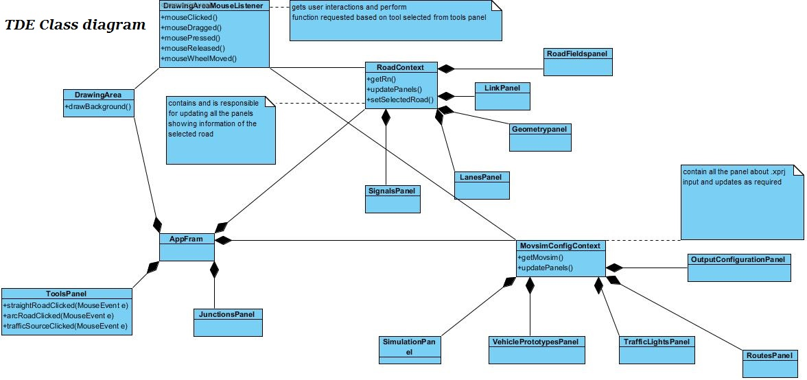

## **Technology**

The primary language used is Java and API’s used are apache’s logging Java’s JAXB for xml parsing. Memory requirements changes according to scenarios. Memory requirement increases with increase in mean road length of road network and number of vehicles on the road network.

# Use Case Diagrams and Screenshots

## **Main screen (Scenarios editor tool)**

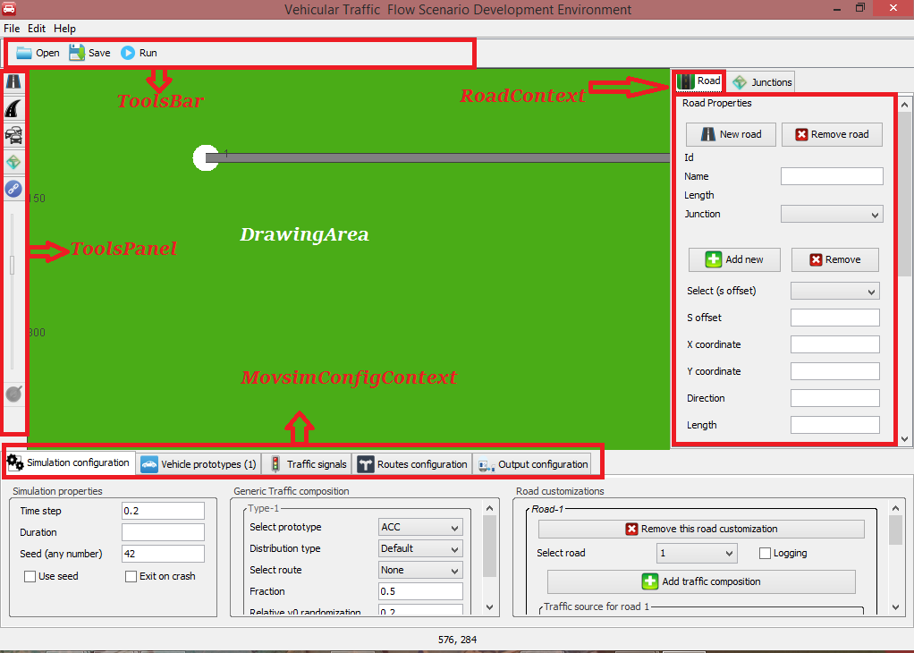

## **Movsim simulator interface (Running Kalma chowk scenario)**

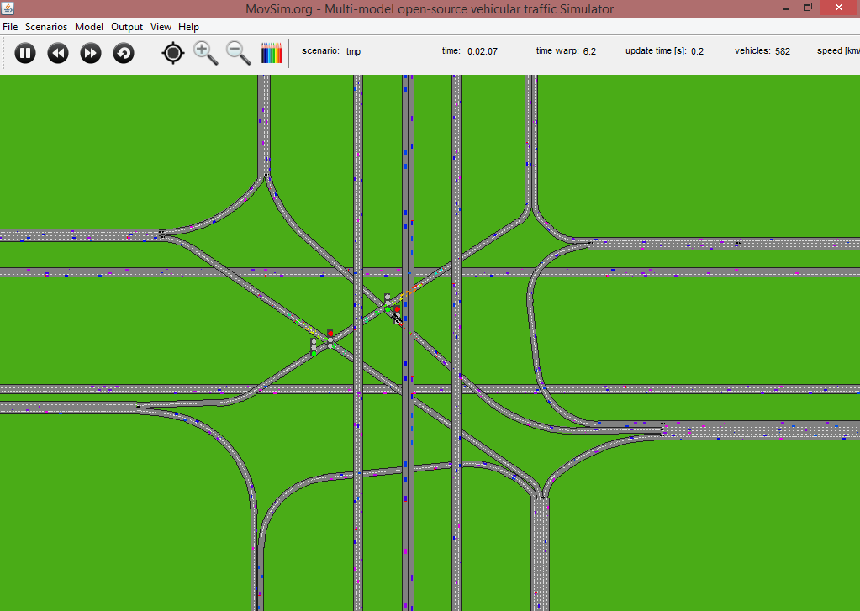

## **Use case diagrams:**

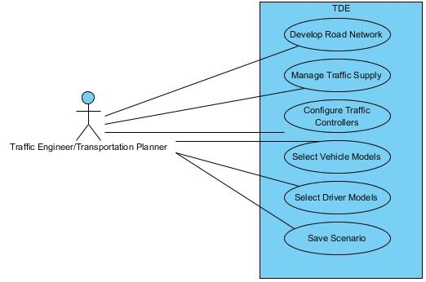

# Road Network infraStructure (.xodr input)

## **Introduction**

For defining and specifying road network Open drive format is used. And file extension for saving and loading road networks is .xodr.

A brief overview is given below, for details please find OpenDrive schema and specification document on: en.wikipedia.org/wiki/OpenDRIVE_(specification) and [www.opendrive.org](http://www.opendrive.org)

* + 1. Road
       1. Geometry (x,y,hdg,sOffset etc)
       2. Link
          1. Predecessor
          2. Successor
       3. Lanes
          1. Width
          2. Speed limit
       4. Signals
          1. position
    2. Controller
       1. Controls
    3. Junctions
       1. Connection
          1. LaneLink

## **Road**

In whole network there can be 1 to multiple instances of roads every road having different properties and unique ids. Every road has its geometry which tells either road is straight or arc, tells its length, heading angle in radian. Link of the road tells which road is predecessor and which road is successor. Link is optional. A road also have lanes of some provided width, id, and speed limits and having ids of predecessor/successor lanes. Road have optionally signals too each signal is defined by an id which is used in controller to control these signals. A road can have more than 1 geometry if so poly road mapping is created.

## **Controller**

A Controller controls different signals concurrently added to it. To add a signal we have to add a control to controller and control has the id of signal to be controlled. All the signal must be controller by some controller otherwise Exception will be thrown and scenario halts.

## **Junction**

A junction is needed when there are more than 1 predecessors or successors of a road or in other words when there is ambiguity deciding predecessor or successor. In such case single road to which attached more than one roads is called connecting road and other roads are called incoming road as shown in figure.

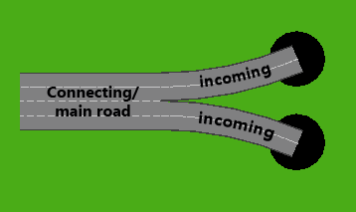

While developing such scenario we have to mark connecting road as junction before any link is created. More 2 connecting roads/marked as junctions cannot be connected directly they need to be attached by an intermediate road. There is still need to improve this tool and is included in future work.

In a junction 1 lane can only be connected to 1 lane. There can be as many connections in a junction as 2 roads are paired in unique combinations. For example in above case there can be 2 pair combinations connecting road to incoming road 1 and incoming road 2 so there are 2 connections in this junction.

# Movsim (.xprj input)

## **Introduction**

This is another input of the application. It contains configurations of simulation and simulator, vehicle types, road customizations, routes and output etc. For further details please refer to Movsim schema file.

A brief overview is given below:

* Vehicle Prototypes
  + VehiclePrototypeConfiguration
    - AccelerationModelType
      * ModelparameterIDM
      * ModelparameterACC
      * ModelparameterNSM
      * ModelparameterKrauss
      * ModelparameterGipps
      * ModelparameterNewell
    - LaneChangeModelType
      * Mobil
* Scenario
  + Simulation
    - TrafficCompostion
      * VehicleType
    - Road
      * TrafficComposition
      * InitialCondition
      * TrafficSource
  + TrafficLights
    - ControllerGroup
  + Routes
    - Route
      * Road
  + Outputconfiguration
    - FloatingCarOutput
    - TravelTimes

## **Simulation**

### Generic Traffic composition

A traffic composition tells which vehicle prototype to be used and which route these vehicles should follow. A traffic compositions can 1 or more types each type composes whole traffic according to its fractional weight.

### Road customizations

Simulation tab also contains road customizations panel to customize any road. Here traffic composition, logging, traffic sources, inflow configurations etc. are defined for that specific road. This is place where we tell that a road should run only buses and what should be the traffic density on road.

## **Vehicle Prototypes**

Vehicle prototypes decide which type of the traffic will run on road network. Vehicle properties like length, width, max deceleration, driving models and parameters and lane change models etc. are defined.

## **Traffic Signals**

Every controller defined in .xodr file should also be referred in .xprj with controller groups.

Every controller’s id matches related controller’s id. Every control should refer to some valid signal set on road. A controller group controls all those signals referred by related controller. Each controller groups has can have phases of traffic light states. Each phase is defined by time duration along with traffic light state. At end of last phase first phase repeats itself and cycle restarts.

A traffic light state tells controller which signal should be in which state (RED, GREEN, YELLO and ORANGE) in a given phase.

## **Routes**

In order to make vehicles to follow a given sequence of road a route is defined. At time of configuring traffic composition we can tell any Vehicle type which road it should follow. Road sequence must be valid e.g. if sequence is 4,7,41 then 7 must be predecessor of 4 and 41 of 7. Routes are used when we want to route our traffic to some other road in a junction which has more than 1 predecessor. In a sequence of road not including junction route is of no use.

## **Output Configuration**

### Floating Cars Output

To get vehicles state we can use two techniques. Firstly we can pause a running simulation and can hover over a vehicle to get its status or we can generate each vehicle’s stats in form of comma separated values (CSV). A sample is attached below



### Travels Time

Travels time gives information about whole scenario in form of stats.



|  |
| --- |
| DISCUSSION AND CONCLUSIONS |

## **Conclusions**

As use of computer simulations in different fields is increasing a lot of work is going on traffic simulation too. Movsim is an example of multi-modal traffic simulator. But due to adopted open drive standard it was difficult to develop scenarios for Movsim. TDE helps users to develop very complex scenarios efficiently, correctly, with ease and visually in very less time. TDE also configures the simulations parameters graphically creating other output file to be used by Movsim.

Due to multi model simulator user don’t have to switch other simulators to avail functionality of other models. Scenarios can also be saved at any point and loaded again from same point where left. With graphical representation, status of whole simulation can also be seen through output data generated by simulator in form of logs and csv files.

# RECOMMENDATIONS AND FUTURE WORK

## **Future work**

### Development work

While searching a road, improved algorithm can be used in roads are sorted with respect to some specific attributes like x, y coordinates to improve efficiency of TDE. More tools can be added to tools panel to make it user friendly. Still only junction having only one connecting road and all others roads being incoming roads, have been implemented although junctions can have more than one connecting and incoming roads. Traffic lights can be placed graphically by drag and drop. Only theme state is preserved while closing application other configuration can also be implemented to be preserved.

Undo and redo functionality is not implemented yet. Short cut keys and key listener needs to be implemented. Elevation profiles to be implemented yet.

An adapter to be developed to adapt Open Street map data to TDE compatible input. When simulator window is closed simulation thread is still running in background until TDE window is closed.

# Further reading/documentation

## **Link references**

Open drive schema/ [www.opendrive.org/tools/OpenDRIVE_1.3.xsd](http://www.opendrive.org/tools/OpenDRIVE_1.3.xsd) , <http://en.wikipedia.org/wiki/OpenDRIVE_(specification)>



Movsim configuration Schema



Road network format specifiation/ <http://www.opendrive.org/docs/OpenDRIVEFormatSpecRev1.3D.pdf>



Movsim recommendations



## **API Specifications**

Descripton of each class and methods can be found in API specification documents.



# REFERENCES

[1] Drew, D.R.

(1968) Traffic flow theory and control

[2] Daniel L. Gerlough

(1955) Simulation of Freeway Traffic on a General-purpose Discrete Variable Computer

[3] Martin Fellendorf and Peter Vortisch

Microscopic Traffic Flow Simulator VISSIM

[4] Richard W. Rothery

Car Following Models [University of Texas, Austin]

[5] www.logging.apache.org/log4j/

[6]http://en.wikipedia.org/wiki/OpenDRIVE_(specification)

# How to use the tool

## **Tools panel**

Tool panel provides easy to use selectors to edit scenario. It contains buttons which are in two states either pressed or released.

Cursor changes according to tool selected.

Default tool selected is selection tool when no tool is selected from tools panel default tool is active.

### Straight road tool

This tool is used to add new straight road. If on canvas is cliked road is added on position where click occured if auto locate feature is not being used otherwise road is placed at end of the last road. When click occurs on road new road is automatically attached to clicked road as predecessor with same number of lanes with same lane widths.

### Arc road tool

This tool is used add new arc road. This also work same as straight tool just geometry is arc instead of line.

### Traffic Source tool

This tool is used to add traffic source to a road. In simulation if a road doesn’t have traffic source there will not be any traffic on that road. After selecting this tool any tool on which we click is automatically configured to use traffic source with default values. Traffic source is represented with a white circle at start of road and traffic sink with black circle at end of the road.

### Linker tool

This tool is used to link roads together. A road can be predecessor or successor of another road. To create link we just have to click on predecessor road’s lane and then on lane to which we want to connect it.

### Junctions Editor

In order to link road in junctions we first need to mark a connecting road as junciton. This tool is used to select roads which are part of a junciton either connecting or incoming. While marking we have to select a connecting road.

### Drawing Area

A road can be dragged to desired location by selecting is first by clicking on it. A road can be dragged only when it is selected. A roads different properties can be modified with right click menu shown below: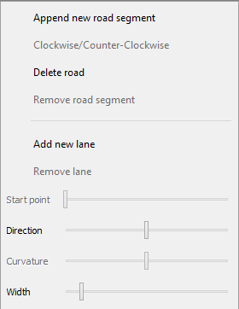

All the properties can also be modified throgh Road tab which shows properties of the selected road.

For more on this topic refer to provided videos on how to use the tool. Canvas can be dragged while any tool is selected and road is not being dragged. Mouse wheel is used for zooming in and out the canvas.

Further functionality is self descriptive on all tabs. In case of any query please contact on [shmeelahmad@gmail/yahoo/hotmail.com](mailto:shmeelahmad@gmail/yahoo/hotmail.com)